***EXERCICIS “BANC DE PROVES”***

Informació:  
  
a) [***https://www.genbeta.com/herramientas/siete-benchmarks***](https://www.genbeta.com/herramientas/siete-benchmarks-para-medir-la-potencia-bruta-de-tu-ordenador-en-windows-macos-y-gnu-linux)

b) [***https://www.howtogeek.com/111733/how-to-benchmark-your-windows***](https://www.howtogeek.com/111733/how-to-benchmark-your-windows-pc-5-free-benchmarking-tools/)

Executar programa de benchmark (posiblement novabench)

1. Omplir la seguent tabla

|  |  |  |  |  |  |  |  |
| --- | --- | --- | --- | --- | --- | --- | --- |
|  | Intel i7-4702MQ  (Portatil) | Intel i5 11400  (Sobremesa) | % millora |  | Intel i7-4702MQ | AMD Ryzen 5  3600 | % millora |
| CPU Score | 597 | 1450 | 142% |  | 597 | 1156 | 93% |
| RAM Score | 243 | 284 | 16% |  | 243 |  |  |
| Disk Score | 84 | 94 | 11% |  | 84 |  |  |

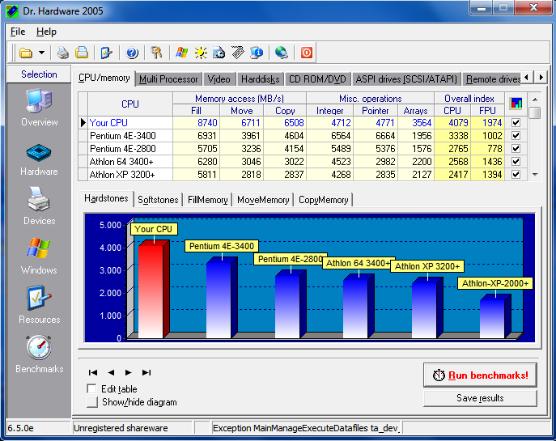

3) Cercant les puntuacions i completar tabla:  
 <https://www.cpubenchmark.net/cpu.php?cpu=Intel+Core+i7-12700&id=4669>

**CPU Mark Relative to Top 10 Common Desktop CPUs**

|  |  |  |  |  |  |  |  |
| --- | --- | --- | --- | --- | --- | --- | --- |
|  | Intel i5 11400 | Intel Core i7-12700 | % millora |  | Intel i5 11400 | AMD Ryzen 7 5700G | % millora |
| CPU Mark | 17103 | 30959 | 81% |  | 17103 | 24670 | 44% |
| Price | $139USD | $325USD |  |  | $139USD | $167USD |  |

4) Realitzar dues tables iguales als exercicis 3, pero amb altres dades de <https://www.cpubenchmark.net/cpu_value_available.html>

Mateix model però diferent generació

|  |  |  |  |  |  |  |  |
| --- | --- | --- | --- | --- | --- | --- | --- |
|  | AMD Ryzen 5 5500 | AMD Ryzen 5 4500 | % millora |  | AMD Ryzen 3 3100 | AMD Ryzen 3 4100 | % millora |
| CPU Mark | 19556 | 16221 | 20% |  | 11635 | 11041 | 5% |
| Price | $85USD | $75USD |  |  | $71USD | $65USD |  |